SPEED CONTROL OF DC MOTOR THROUGH PWM



## A mini project Report was submitted in partial fulfillment of the requirement for the award of the degree

**BACHELOR OF TECHNOLOGY**

In

**ELECTRONICS &COMMUNICATION ENGINEERING**

By

## SHIVAPRIYA.P 19K41A04A9

## K.RAJASHEKAR REDDY 19K41A04A1

## V.RAMU 19K41A0488

## R.KARTHIK 19K41A0484

## Under the guidance of

**Dr. T. LAXMAN RAJU**

## Associate professor, Department of ECE



**CERTIFICATE**

## This is to certify that this project entitled “SPEED CONTROL OF DC MOTOR THROUGH PWM” is the bonafide work carried out by P.Shiva Priya, K. Rajashekar reddy, V. Ramu , R. Karthik Rathod as a minor project in the partial fulfillment of the requirement for the award of degree BACHELOR OF TECHNOLOGY in ELECTRONICS & COMMUNICATION ENGINEERING from JAWAHARLAL NEHRU TECHNOLOGICAL

## UNIVERSITY, HYDERABAD during the academic year 2020-2021 under our guidance and Supervision.

#### Dr. T. LAXMAN RAJU Dr. SANDIP BHATTACHARYA

Associate Professor & Guide, Professor & HOD(ECE)

S R Engineering College, S R Engineering College,

Ananthasagar, Warangal. Ananthasagar, Warangal.

# ACKNOWLEDGEMENT

## We wish to take this opportunity to express our sincere gratitude

## and a deep sense of respect to our beloved principal, **Dr. V. Mahesh**, SR Engineering College, Ananthasagar, Warangal, for making us available all the required assistance and for his support and inspiration to carry

## out this work in the institute.

## We owe an enormous debt of gratitude to Dr. SANDIP BHATTACHARYA, HOD of the ECE Department, and as well as our project guide Dr. T. LAXMAN RAJU , Assistant Professor for guiding us from the beginning through the end of the project with their intellectual advice and insightful suggestions. We truly value their consistent feedback on our progress, which was always constructive and encouraging and ultimately drove us in the right direction.

## I also thank the other staff members and friends who assisted us. Finally, I thank my parents who inspired us always to do our best.

**ABSTRACT**

In this project, we are going to explain how Speed Control of DC Motor can be implemented using 555 timer and Pulse Width Modulation (PWM).

The dc motor speed is controlled by using power electronic device which is the PWM technique. The speed pulse train will be based on required input speed. This circuit is useful to operate the dc motors at required speed with very low losses and low cost. The circuit response time is fast. Hence high reliability can be achieved. The designed circuit was tested for various speed inputs satisfactorily. The method already employed in traction system and has a good scope ahead.

**CONTENTS**

*ACKNOWLEDGEMENT iii*

*ABSTRACT iv*

*LIST OF FIGURES vii*

|  |  |  |  |
| --- | --- | --- | --- |
| **Chapter No.** | **Title** | **Page No.** |  |
| **1** | **INTRODUCTION** |  | 01 |

* 1. INTRODUCTION 01
  2. EXISTING METHODS 01
  3. PRESENT WORK 04
  4. LITERATURE SURVEY 05

# HARDWARE / SOFTWARE TOOLS

* 1. HARDWARE TOOLS 06

|  |  |  |
| --- | --- | --- |
| 2.1.1 | 555 TIMER WORKING | 06 |
| 2.1.2 | TRANSISTORS | 06 |
| 2.1.3 | DC MOTOR | 07 |
| 2.1.4 | POTENTIOMETER | 08 |
| 2.1.5 | RESISTORS | 08 |
| 2.1.6 | CAPACITORS | 08 |
| 2.1.7 | DIODES | 09 |

1. **PROJECT IMPLEMENTATION**
   1. PROPOSED PROJECT 10
   2. DESCRIPTION OF PROPOSED PROJECT 10

# SIMULATION RESULTS & ANALYSIS 12

# CONCLUSION & FUTUTRE SCOPE

* 1. CONCLUSION 15
  2. FUTURE SCOPE 15

# BIBILOGRAPHY 16

**LIST OF FIGURES**

**Figure No. Figure name Page No.**

1. Flux control method 02
2. Armature control method 02
3. Voltage control method 03
4. IC 555 Timer 06
5. Darlington pair NPNN Transistor 07
6. DC Motor 07
7. Potentiometer 08
8. Resistors 08
9. Capacitors 08
10. Diodes 09
11. Block disgram of proposed project 10
12. Hardware of proposed project 10
13. Hardware arrangement of proposed system 12

**CHAPTER-1 INTRODUCTION**

* 1. **INTRODUCTION**

In this project, we are going to explain how Speed Control of DC Motor can be implemented using 555 timer and Pulse Width Modulation (PWM). Most of the industrial process requiresto be run on the certain parameters where speed of the drive is concerned. The electric drive systems used in many industrial applications require higher performance, reliability, variable speed due to its ease of controllability. The speed control of DC motor is important in applications where precision and protection are of essence. Purpose of a motor speed controller is to take a signal representing the required speed and to drive a motor at that speed. In this project controller presented uses the pulse width modulation (PWM) technique for speed control of DC motor. We use DC Motors in many systems in our day to day life. For example, CPU fans, fume extinguishers, toy cars etc. are all DC Motors which are operated by DC power supply. Most of the times we will have to adjust the speed of the motors as per our requirement. A CPU Fan for example, must be operated at high speed when the CPU is preforming heavy tasks like games or video editing. But for normal usage like editing documents, the speed of the fan can be reduced. Although some systems have an automatic adjustment system for fan speed, not all systems possess this functionality. So, we will have to adjust the speed of the DC Motor ourselves occasionally. The circuit is used to control speed of DC motor by using PWM technique.

Series Variable Speed DC Motor Controller 12V uses a 555 timer IC as a PWM pulse generator to regulate the motor speed DC12 Volt. IC 555 is the popular Timer Chip used to make timer circuits. In the Astable mode (AMV), the IC works as a free running multivibrator. The output turns high and low continuously to give pulsating output as an oscillator.

* 1. **EXISTING SYSTEMS of speed controlling of dc motor**

#### Flux Control Method :

flux control method to control the speed of a dc shunt motor

It is already explained above that the speed of a dc motor is inversely proportional to the flux per pole. Thus by decreasing the flux, speed can be increased and vice versa.

To control the flux, a rheostat is added in series with the field winding, as shown in the circuit diagram. Adding more resistance in series with the field winding will increase the speed as it decreases the flux. In shunt motors, as field current is relatively very small, Ish2R loss is small. Therefore, this method is quite efficient. Though speed can be increased above the rated value by reducing flux with this method, it puts a limit to maximum speed as weakening of field flux beyond a limit will adversely affect the commutation.

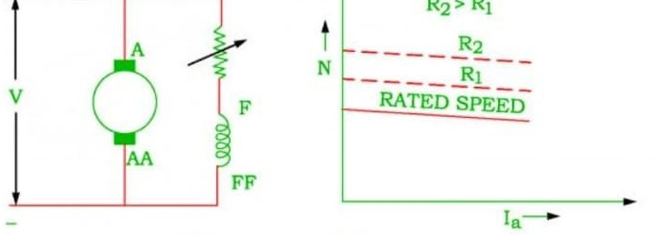

FIG 1: Flux Control Method

#### Armature Control Method :

Armature control method to control the speed of a shunt motor Speed of a dc motor is directly proportional to the back emf Eb and Eb = V - IaRa. That means, when supply voltage V and the armature resistance Ra are kept constant, then the speed is directly proportional to armature current Ia. Thus, if we add resistance in series with the armature, Ia decreases and, hence, the speed also decreases. Greater the resistance in series with the armature, greater the decrease in speed.

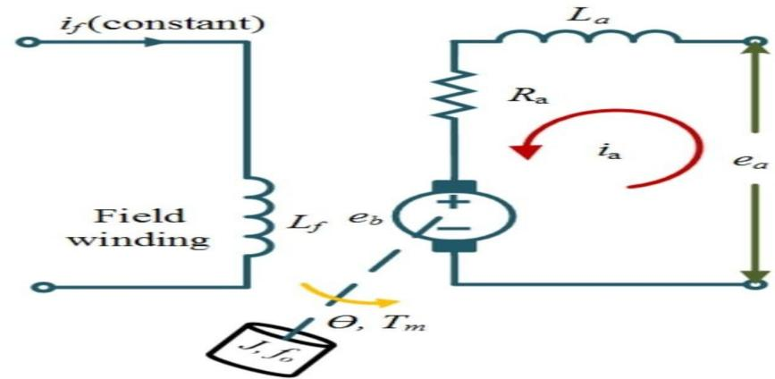

FIG 2: Armature Control Method

#### 1.2.3. Voltage Control Method :

FIG 3: Voltage Control Method

#### Multiple voltage control:

In this method, the shunt field is connected to a fixed exciting voltage and armature is supplied with different voltages. Voltage across armature is changed with the help of suitable switchgear. The speed is approximately proportional to the voltage across the armature.

#### Ward-Leonard System:

ward leonard system speed control of dc motor This system is used where very sensitive speed control of motor is required (e.g electric excavators, elevators etc.). The arrangement of this system is as shown in the figure at right.

M2 is the motor to which speed control is required.

M1 may be any AC motor or DC motor with constant speed. G is a generator directly coupled to M1.

In this method, the output from generator G is fed to the armature of the motor M2 whose speed is to be controlled. The output voltage of generator G can be varied from zero to its maximum value by means of its field regulator and, hence, the armature voltage of the motor M2 is varied very smoothly. Hence, very smooth speed control of the dc motor can be obtained by this method.

#### Speed Control Of Series Motor :

Speed control of dc series motor.

**Field diverter:** A variable resistance is connected parallel to the series field as

This variable resistor is called as a diverter, as the desired amount of current can be diverted through this resistor and, hence, current through field coil can be decreased. Thus, flux can be decreased to the desired amount and speed can be increased.

**Armature diverter:** Diverter is connected across the armature as for a given constant load torque, if armature current is reduced then the flux must increase, as Ta ∝ ØIa

This will result in an increase in current taken from the supply and hence flux Ø will increase and subsequently speed of the motor will decrease.

1. **Tapped field control:** field coil is tapped dividing number of turns. Thus we can select different value of Ø by selecting different number of turns.

#### Variable Resistance In Series With Armature

By introducing resistance in series with the armature, voltage across the armature can be reduced. And, hence, speed reduces in proportion with it.

#### Series-Parallel Control

This system is widely used in electric traction, where two or more mechanically coupled series motors are employed. For low speeds, the motors are connected in series, and for higher speeds, the motors are connected in parallel.

When in series, the motors have the same current passing through them, although voltage across each motor is divided. When in parallel, the voltage across each motor is same although the current gets divided.

* 1. **PRESENT WORK This is with IC555 timer.**

Speed Control of DC Motor can be implemented using 555 timer and Pulse Width Modulation (PWM). Most of the industrial process requires to be run on the certain parameters where speed of the drive is concerned. The electric drive systems used in many industrial applications require higher performance, reliability, variable speed due to its ease of controllability. The speed control of DC motor is important in applications where precision and protection are of essence. Purpose of a motor speed controller is to take a signal representing the required speed and to drive a motor at that speed. In this project controller presented uses the pulse width modulation (PWM) technique for speed control of DC motor.

* 1. **LITERATURE SURVEY**

Dc motor are mostly used in industries so we usedto governthe rate of the motor with the aid of usingthe usage of PWM. In this paper, to governthe rateof DC motor the usage of Pulse Width Modulation (PWM) method. Microcontroller AT89S52 is used to generate PWM. L293D IC is used to power the motorthat'smade of H-Bridge. 555 IC is used with opto

coupler to experiencethe rate of DC motor. Rectifier circuit is used for power deliver to circuit and motor. This paper indicatesthat particularand correctmanage of small DC automobileswith outthe usage ofluxurious components.

Hence , the speed control of the motor is controlled by the PWM which is generated via microcontroller and it is Low cost, It is reliable one, It is efficient and long lasting, The speed will be in constant at different loads, It is more comfortable to use in industries for speed control of the motors. Our project is discussed on base of the pulse width modulation.

The speed control of DC (DC) motor for various applications is extremely important. especially requirement, setting a speed DC motor becausethe driving equipment must be performed remotely. thereunder condition, conducted a search on a DC motor speed control with pulse width modulation (PWM) method of the infrared remote. PWM is method which will be used as a efficient DC motor speed control. Controller used TV remote to send data to ATmega16 microcontroller through the IR receiver. This command controls the L293D driver IC to regulate the direction and speed of a DC motor.To calculate the speed of a DC motor, perforated disk attached to the motor shaft isemployed and placed between the photodiode as a sensor and therefore the LED. The results of the research are the direction and speed of a DC motor are often set from the infrared remote with PWM method using ATmega16 microcontroller. Furthermore, the results of those settings are often displayed on the LCD every 7 seconds.

DC motors have many advantages in technical and economic aspect. Therefore DC motor is widelyused in the economic world. A DC motor that has small power and little starting current be operatedby connecting and starting it on to a voltage source through an influence switch. However, for thistype of motor with a bigger capacity, this can't be done because the present generated when startingwill be large. the quantity of the starting current is suffering from themassive load connected to the motor.Large staring currents that occur for anextended time or are always repeated will cause damage to the motorand electrical power system where the motor is installed.This paper presents a way for controlling the quantity of current drawn by a DC motor whenstaring by using controls utilizing a microcontroller. subsequent a part of this paper may be a brief description ofDC static magnet motors, PIC microcontrollers used, experimental methods and results obtained.

**CHAPTER 2 HARDWARE TOOLS**

* 1. **HARDWARE TOOLS**

## 555 TIMER WORKING:

The 555 generally operates in 3 modes:

* + - 1. Astable
      2. Mono-stable
      3. Bi-stable modes.

In this circuit, Astable mode is being used. This means there will be no stable level at the output. So, the output will be swinging between high and low. This character of unstableoutput is used as a clock or square wave output for many applications.

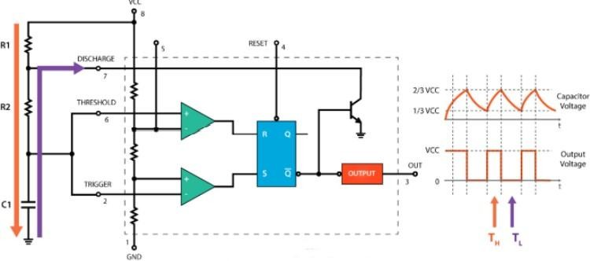

## FIG 4: IC 555 TIMER

* + 1. **TRANSISTOR:**

In this circuit, we use TIP122 (Darlington NPN) transistor. The TIP122 is a Darlington pair NPN transistor. It functions like a normal NPN transistor, but since it has a Darlington pair inside it has a good collector current rating of about 5A and a gain of about 1000. It can also withstand about 100V across its collector- Emitter hence can be used to drive heavy loads. The Darlington pair inside this transistor is shown clearly as its internal circuit schematic below

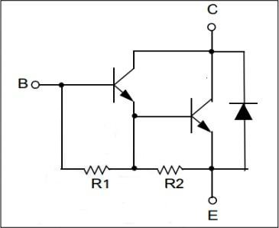

FIG 5: DARLINGTON PAIR NPNN TRANSISTOR

**APPLICATION:**

* Can be used to switch high current (upto 5A) loads
* Can be used as medium Power switches
* Used where high amplification is needed
* Speed control of Motors
* Inverter and other rectifier circuit.

#### DC MOTOR

* A DC motor is any of a class of rotary electrical machines that converts direct current electrical energy into mechanical energy. The most common types rely on the forces produced by magnetic fields. Nearly all types of DC motors have some internal mechanism, either electromechanical or electronic, to periodically change the directionof current flow in part of the motor.

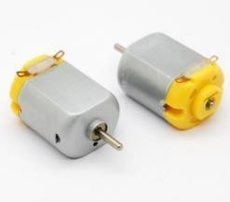

FIG 6 **.**DC MOTOR

#### POTENTIOMETER

A potentiometer is a three-terminal resistor with a sliding or rotating contact that forms an adjustable voltage divider. If only two terminals are used, one end and thewiper, it acts as a variable resistor or rheostat. In this project, we use 100 KΩ potentiometer.

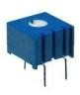

. Fig.7. POTENTIOMETER

#### 2.1.3 RESISTORS:

* A resistor controls the flow of the electrical current within a circuit.
* Resistors are made from materials like copper or carbon, which make it difficult for the electrical charges to flow through a circuit.

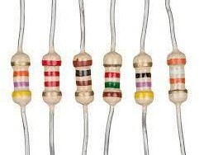

. Fig.8 RESISTORS

#### CAPACITORS:

* + - * capacitors are widely used in electronic circuits for blocking direct current while allowing alternating current to pass.
      * In analog filter networks, they smooth the output of power supplies. In resonant circuits they tune radios to particular frequencies.

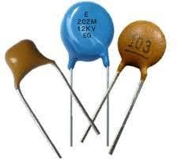

. Fig.9. CAPACITORS

#### DIODES:

## diode, an electrical component that allows the flow of current in only one direction. In circuit diagrams, a diode is represented by a triangle with a line across one vertex.

## There are various types of diodes, but the ones being discussed here are Zener, Rectifier, Schottky, Transient Voltage Suppressor, Thyristor, Silicon Controlled Rectifier, and TRIAC.

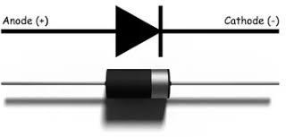

. Fig.10 DIODES

**CHAPTER 3 PROECT IMPLEMENTATION**

* 1. **PROPOSED PROJECT**

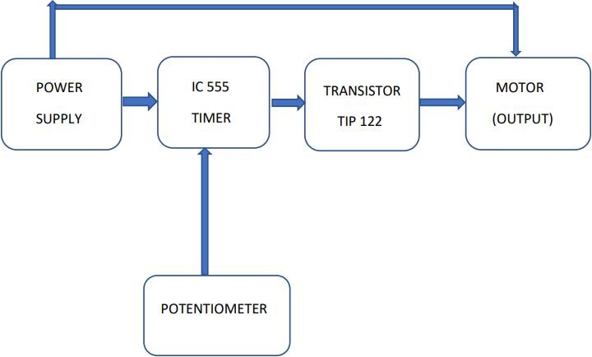

Fig 11 **.**Block Diagram of proposed project

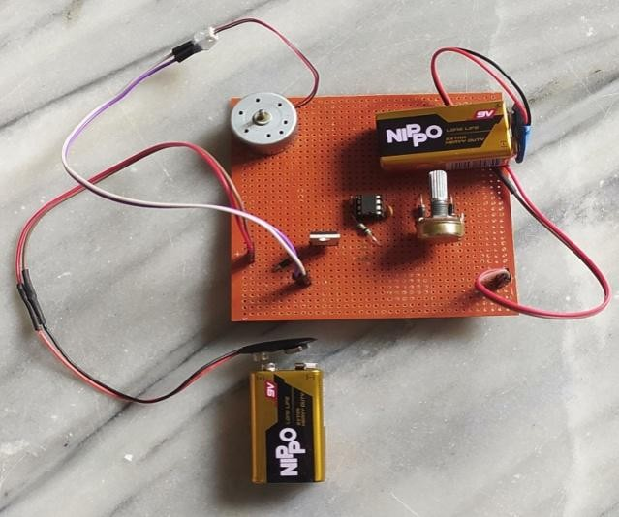

Fig 12 Hardware of proposed project

* 1. **DESCRIPTION OF PROPOSED PROJECT**

The 555 Timer is capable of generating PWM signal when set up in an astable mode. In this circuit, the DC motor is operated by a 555 integrated circuit. The IC 555 in this circuit is being operated in astable mode, which produces a continuous HIGH and LOW pulses. In this mode, the 555 IC can be used as a pulse width modulator with a few small adjustments to the circuit. The frequency

of operation of the circuit is provided by the passive parameters

of resistances and capacitors attached to it. Here’s a basic circuit of the 555 Timer operating in an astable mode and we can notice that the output is HIGH when the capacitor C1 is charging through the resistors R1 and R2. On the other hand, the output of the IC is LOW when the capacitor C1 is discharging but only through the resistor R2. So, we can notice thatif we change the values of any of these three components, we will get different ON and OFF times, or different duty cycle of the square wave output signal. An easy and instant way to do this is to replace the R2 resistor with a potentiometer, and additionally add two diodes inthe circuit. In this configuration the ON time will depend on the resistor R1, the left side of the potentiometer and the capacitor C1, while the Off time will depend on the capacitor C1 and the right side of the potentiometer. We can also notice that in this configuration the period of one cycle, thus the frequency, will always be the same, because the total resistance, while charging and discharging, will remain the same. Usually the R1 resistance is much smaller than the resistance of the potentiometer, for example, 1K compared to 100K of the potentiometer. In that way we have 99% control over the charging and discharging resistance in the circuit. The control pin of the 555 Timer is not used but it’s connected to a 100nF capacitor in order to eliminate any external noise from that terminal. The reset, pin number 4, is active low so therefore it is connected to VCC in order to prevent any unwanted reset of the output. The output of the 555 timers can sink or source a current of 200mA to the load. So, if the motor that we want to control exceeds this rating we need to use a transistor or a MOSFET for driving the motor. In this circuit, I used a (TIP122) Darlington transistor which can handle a current up to 5A.

**CHAPTER 4**

**HARDWARE ARRANGEMENT OF THE PRODUCT :**



Fig.13 Hardware arrangement of proposed system

**RESULTS AND ANALYSIS : Step 1:** Connect the connecting wires properly and also connect the power supply.

Fig.13:Hardware arrangement of proposed system

**Step 2:** Start adjusting the potentiometer that is start rotating, which varies the resistance and voltage flowing throughing it.

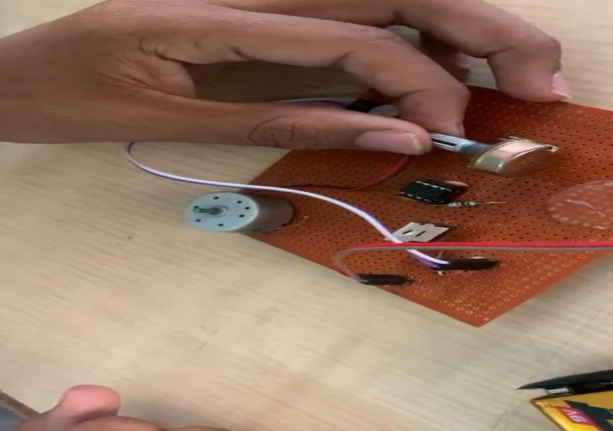

Fig.13:Hardware arrangement of proposed system

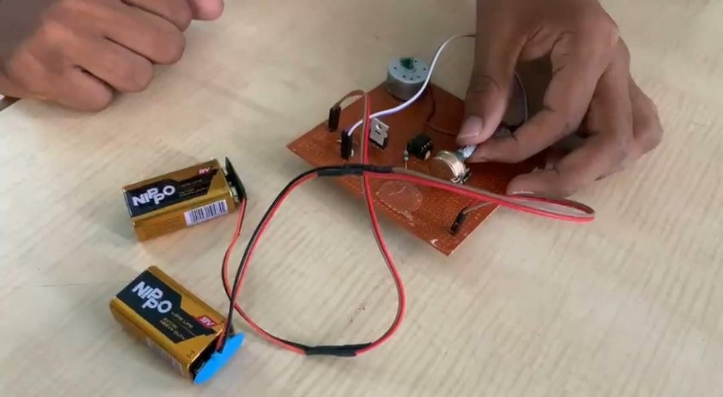**Step 3:** Now slowly increase the speed of DC motor through increasing and adjusting the potentiometer which varies the resistance and voltage flowing through it.

Fig.13:Hardware arrangement of proposed system

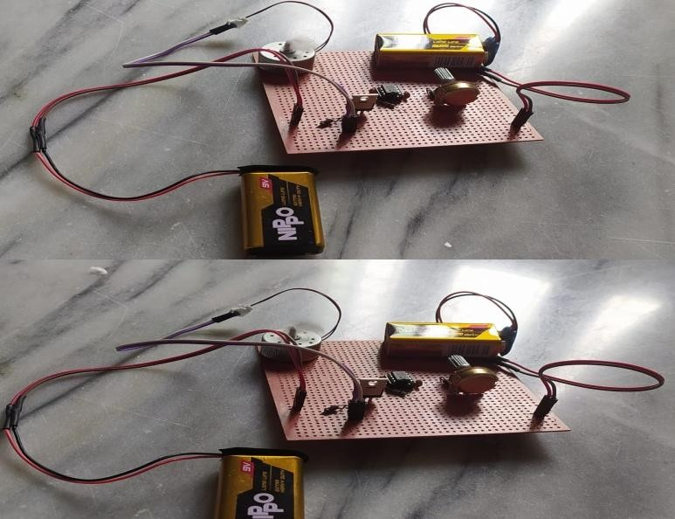**Step 4:** And leave the potentiometer , the DC motor keeps on rotating.

Fig.13:Hardware arrangement of proposed system.

**CHAPTER 5 CONCLUSION AND FUTURE SCOPE**

* 1. **CONCLUSION**

The dc motor speed is controlled by using power electronic device which is the PWM technique. The speed pulse train will be based on required input speed. This circuit is useful to operate the dc motors at required speed with very low losses and low cost. The circuit response time is fast. Hence high reliability can be achieved. The designed circuit was tested for various speed inputs satisfactorily. The method already employed in traction system and has a good scope ahead.

* 1. **FUTURE SCOPE**
     1. DC motor plays a significant role in modern industries. They are widely used in industry because of its low cost, less complex control structure and wide range of speed and torqueso better future of this project.
     2. In this project we are used pulse width modulation technique, it is a modern technologyin solid state field and it provide smooth speed control of motor.
     3. Now a day PWM technique are using in fuzzy logic control system, so PWM method is very efficient and reliable method to control the speed of motor so it future is also bright inthe modern era with fuzzy logic.

**BIBLIOGRAPHY**

1. VasundharaRamireddy, G. Varsha, A. Sharath Kumar, Alcohol Detection and Vehicle Ignition Locking System, International Journal of Mechanical Engineering and Technology 9(8), 2018, pp. 1078–1084.
2. Jaimano Varghese, Binesh Ellupurayil Balachandran , “Low Cost Intelligent Real Time Fuel Mileage Indicator for Motorbikes”,International Journal of Innovative Technology and Exploring Engineering (IJITEE) ISSN: 2278-3075, Volume-2, Issue- 5, April 2013.
3. Joel Sachin, Kiran Rana Gill “ Anti-Theft System For Vehicles Using Fingerprint Sensor International Journal Of Scientific & Engineering Research, Volume 7, Issue 7,

July-2016 1436 ISSN 2229-5518

1. Japan 2006 [10]. Pritpal Singh, Tanjot Sethi, Bibhuti Bhusan Biswal, and Sujit Kumar Pattanayak” A Smart Anti-theft System for Vehicle Security”International Journal of Materials, Mechanics and Manufacturing, Vol. 3, No. 4, November 2015
2. Nirosha, et al., "Alcohol Detection In Vehicles" , International Research Journal of Engineering and Technology (IRJET), vol. 4, issue 4, pp. 2025-2030, Apr 2017.
3. P. Verma and J. Bhatia, "Design and Development of GPS-GSM based Tracking System with Googlemap based Monitoring," International Journal of Computer Science, Engineering and Applications (IJCSEA), vol. 3, no. 2, June 2013
4. Kunal D. Dhande, Sarang R. Gogilwar, SagarYele, “Fuel Level Measurement Techniques”, Systematic Survey International Journal of Research in Advent Technology, Vol.2, No.4, April 2014E-ISSN: 2321-963781
5. Mrs. shubhangi mali, professor J.A.shaikh “ Fingerprint based authentication and security system using GSM and GPS technology” International Journal of Engineering Trends and Technology (IJETT) – Volume-45 Number8 -March 2017
6. Karan Siyal and G. Gugapriya “Anti-Theft Vehicle Locking System using CAN” Indian Journal of Science and Technology, Vol 9(45), DOI: 10.17485/ijst/2016/v9i45/ 105307, December 2016 ISSN (Print) : 0974-6846 ISSN (Online) : 0974-5645.